**Route Suitability Supervision**

**Authors:**

Baseliyos Jacob, Stéphane Besure, Yoann Guyot

**Reviewers:**

Reviewers of this document

**Date and version:**

24/10/2013 - v1 - creation

30/10/2013 - v2 – updated with requirements and variables

04/11/2013 – v3 – fixed author names

**Input documents:**

Subset 26 §3.12.2, §7.4.2.21, §7.4.3.5

**Description**

This function manages supervision of route suitabilities where incompatibilities occur for this train, which can be one of these :

* the loading gauge profile of the train is not included in the list of loading gauges accepted by trackside,
* the list of traction systems accepted by the engine does not include the one received from trackside,
* the axle load category of the train is higher than the permitted one received from trackside.

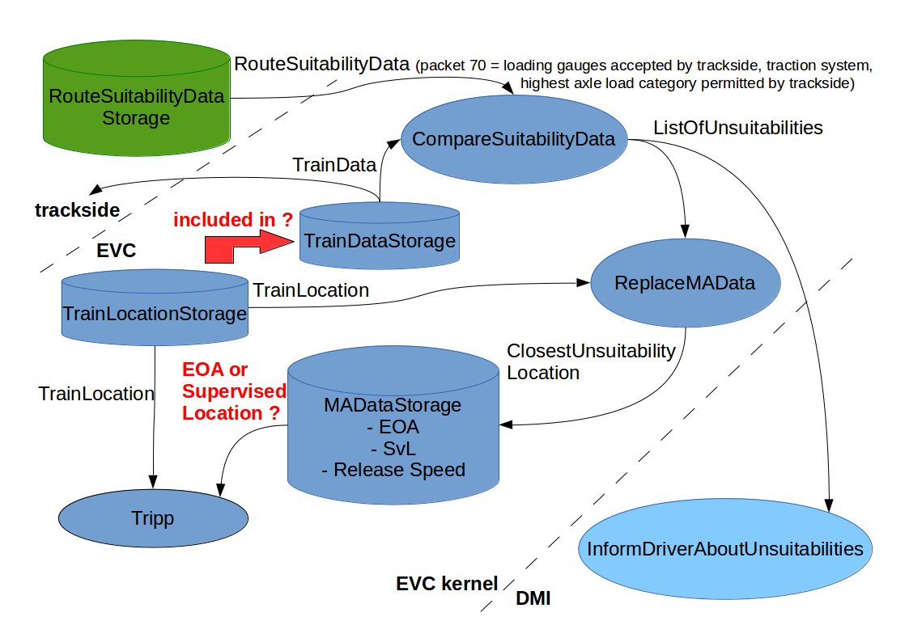

**Functions**

|  |  |  |  |
| --- | --- | --- | --- |
| **Name** | **Occurrence** | **Type** | **Description** |
| Name | 1 | T_Text | **CompareSuitabilityData** |
| Definition | 1 | T_Definition | compares RouteSuitabilityData (Packet70) from trackside with TrainData to determine the list of unsuitabilities |
| *Input* | *0..n* | *T_Variable* | *RouteSuitabilityData (Packet70), TrainData* |
| *Output* | *0..n* | *T_Variable* | *ListOfUnsuitabilities* |
| *Local* | *0..n* | *T_Variable* |  |
| *Parameter* | *0..n* | *T_Constant* |  |
| *Requirement* | *0..n* | *T_Requirement* | SA-1, SA-2, SA-3, SA-4 |
| *Block* | *1 (optional)* | *T_FunctionalBlock* |  |
| *Parent* | *0..1* | *T_Function* |  |
| *Allocation* | *1* | *T_System* | Kernel |
| Safety | 1 | Boolean |  |

|  |  |  |  |
| --- | --- | --- | --- |
| **Name** | **Occurrence** | **Type** | **Description** |
| Name | 1 | T_Text | **ReplaceMAData** |
| Definition | 1 | T_Definition | replaces movement authority data with the closest unsuitability location if there is some |
| *Input* | *0..n* | *T_Variable* | *ListOfUnsuitabilities, TrainLocation* |
| *Output* | *0..n* | *T_Variable* | *ClosestUnsuitabilityLocation* **(also modifies ReleaseSpeed to zero)** |
| *Local* | *0..n* | *T_Variable* |  |
| *Parameter* | *0..n* | *T_Constant* |  |
| *Requirement* | *0..n* | *T_Requirement* | SA-5 |
| *Block* | *1 (optional)* | *T_FunctionalBlock* |  |
| *Parent* | *0..1* | *T_Function* | CompareSuitabilityData |
| *Allocation* | *1* | *T_System* | Kernel |
| Safety | 1 | Boolean |  |

|  |  |  |  |
| --- | --- | --- | --- |
| **Name** | **Occurrence** | **Type** | **Description** |
| Name | 1 | T_Text | **InformDriverAboutUnsuitabilities** |
| Definition | 1 | T_Definition | Informs the driver of all unsuitabilities |
| *Input* | *0..n* | *T_Variable* | *ListOfUnsuitabilities* |
| *Output* | *0..n* | *T_Variable* |  |
| *Local* | *0..n* | *T_Variable* |  |
| *Parameter* | *0..n* | *T_Constant* |  |
| *Requirement* | *0..n* | *T_Requirement* | SA-6 |
| *Block* | *1 (optional)* | *T_FunctionalBlock* |  |
| *Parent* | *0..1* | *T_Function* | CompareSuitabilityData |
| *Allocation* | *1* | *T_System* | DMI |
| Safety | 1 | Boolean |  |

|  |  |  |  |
| --- | --- | --- | --- |
| **Name** | **Occurrence** | **Type** | **Description** |
| Name | 1 | T_Text | **Tripp** |
| Definition | 1 | T_Definition | Tripps the train if, for any reason, it overpassed the ClosestUnsuitabilityLocation |
| *Input* | *0..n* | *T_Variable* | *EndOfAuthority or SupervisedLocation* **<- because the ClosestUnsuitabilityLocation was stored in these variables** |
| *Output* | *0..n* | *T_Variable* |  |
| *Local* | *0..n* | *T_Variable* |  |
| *Parameter* | *0..n* | *T_Constant* |  |
| *Requirement* | *0..n* | *T_Requirement* | * + - 1. SRS-3.12.2.8 |
| *Block* | *1 (optional)* | *T_FunctionalBlock* |  |
| *Parent* | *0..1* | *T_Function* |  |
| *Allocation* | *1* | *T_System* | Kernel |
| Safety | 1 | Boolean |  |

**Variables**

|  |  |  |  |
| --- | --- | --- | --- |
| **Name** | **Occurrence** | **Type** | **Description** |
| Name | 1 | T_Text | RouteSuitabilityData |
| Definition | 1 | T_Definition | Route suitability data defines which values concerning loading gauge, traction system and axle load category a train must meet to be allowed to enter the route. |
| Source | 1 | T_SourceDocument | Subset-26-3 |
| Nature | 1 | T_VariableNature | Packet70 |
| MinimalValue | 0..1 | T_Text |  |
| MaximalValue | 0..1 | T_Text |  |
| SpecialValue | 0..n | T_Text |  |
| Allocation | 1 | * Interface * Packet * Internal |  |
| *Requirement* | *1..n* | *T_Requirement* | *SRS-3.12.2.1,* |
| Store | 0..1 | T_Variable |  |
| Resolution | 0..1 | T_VariableNature |  |
| Safety | 1 | Boolean |  |

|  |  |  |  |
| --- | --- | --- | --- |
| **Name** | **Occurrence** | **Type** | **Description** |
| Name | 1 | T_Text | TrainData |
| Definition | 1 | T_Definition | Train suitability data defines the loading gauge, traction systems and axle load category of the train. |
| Source | 1 | T_SourceDocument | Subset-26-3 |
| Nature | 1 | T_VariableNature |  |
| MinimalValue | 0..1 | T_Text |  |
| MaximalValue | 0..1 | T_Text |  |
| SpecialValue | 0..n | T_Text |  |
| Allocation | 1 | * Interface * Packet * Internal |  |
| *Requirement* | *1..n* | *T_Requirement* | *SA-1, SA-2, SA-3, SA-4* |
| Store | 0..1 | T_Variable | TrainDataStorage |
| Resolution | 0..1 | T_VariableNature |  |
| Safety | 1 | Boolean |  |

|  |  |  |  |
| --- | --- | --- | --- |
| **Name** | **Occurrence** | **Type** | **Description** |
| Name | 1 | T_Text | TrainDataStorage |
| Definition | 1 | T_Definition |  |
| Source | 1 | T_SourceDocument | Subset-26-3 |
| Nature | 1 | T_VariableNature |  |
| MinimalValue | 0..1 | T_Text |  |
| MaximalValue | 0..1 | T_Text |  |
| SpecialValue | 0..n | T_Text |  |
| Allocation | 1 | * Interface * Packet * Internal |  |
| *Requirement* | *1..n* | *T_Requirement* | *SA-1, SA-2, SA-3, SA-4* |
| Store | 0..1 | T_Variable |  |
| Resolution | 0..1 | T_VariableNature |  |
| Safety | 1 | Boolean |  |

|  |  |  |  |
| --- | --- | --- | --- |
| **Name** | **Occurrence** | **Type** | **Description** |
| Name | 1 | T_Text | TrainLocation |
| Definition | 1 | T_Definition | Position of the train, comparable with trackside objects locations. |
| Source | 1 | T_SourceDocument | Subset-26-3 |
| Nature | 1 | T_VariableNature |  |
| MinimalValue | 0..1 | T_Text |  |
| MaximalValue | 0..1 | T_Text |  |
| SpecialValue | 0..n | T_Text |  |
| Allocation | 1 | * Interface * Packet * Internal |  |
| *Requirement* | *1..n* | *T_Requirement* | *SA-5* |
| Store | 0..1 | T_Variable | TrainLocationStorage (defined in another function), or TrainDataStorage ? |
| Resolution | 0..1 | T_VariableNature |  |
| Safety | 1 | Boolean |  |

|  |  |  |  |
| --- | --- | --- | --- |
| **Name** | **Occurrence** | **Type** | **Description** |
| Name | 1 | T_Text | ListOfUnsuitabilities |
| Definition | 1 | T_Definition | List of route suitabilities where incompatibilities occur for this train. |
| Source | 1 | T_SourceDocument | Subset-26-3 |
| Nature | 1 | T_VariableNature |  |
| MinimalValue | 0..1 | T_Text |  |
| MaximalValue | 0..1 | T_Text |  |
| SpecialValue | 0..n | T_Text |  |
| Allocation | 1 | * Interface * Packet * Internal |  |
| *Requirement* | *1..n* | *T_Requirement* | *SA-1, SA-2, SA-3, SA-4* |
| Store | 0..1 | T_Variable |  |
| Resolution | 0..1 | T_VariableNature |  |
| Safety | 1 | Boolean |  |

|  |  |  |  |
| --- | --- | --- | --- |
| **Name** | **Occurrence** | **Type** | **Description** |
| Name | 1 | T_Text | ClosestUnsuitabilityLocation |
| Definition | 1 | T_Definition | * + - 1. The closest location (from the train location) corresponding to the unsuitabilities of ListOfUnsuitabilities |
| Source | 1 | T_SourceDocument | Subset-26-3 |
| Nature | 1 | T_VariableNature |  |
| MinimalValue | 0..1 | T_Text |  |
| MaximalValue | 0..1 | T_Text |  |
| SpecialValue | 0..n | T_Text |  |
| Allocation | 1 | * Interface * Packet * Internal |  |
| *Requirement* | *1..n* | *T_Requirement* | *SA-1, SA-2, SA-3, SA-4* |
| Store | 0..1 | T_Variable |  |
| Resolution | 0..1 | T_VariableNature |  |
| Safety | 1 | Boolean |  |

|  |  |  |  |
| --- | --- | --- | --- |
| **Name** | **Occurrence** | **Type** | **Description** |
| Name | 1 | T_Text | EndOfAuthority |
| Definition | 1 | T_Definition | * + - 1. End of authority |
| Source | 1 | T_SourceDocument | Subset-26-3 |
| Nature | 1 | T_VariableNature |  |
| MinimalValue | 0..1 | T_Text |  |
| MaximalValue | 0..1 | T_Text |  |
| SpecialValue | 0..n | T_Text |  |
| Allocation | 1 | * Interface * Packet * Internal |  |
| *Requirement* | *1..n* | *T_Requirement* | *SA-5, SA-8* |
| Store | 0..1 | T_Variable |  |
| Resolution | 0..1 | T_VariableNature | MADataStorage |
| Safety | 1 | Boolean |  |

|  |  |  |  |
| --- | --- | --- | --- |
| **Name** | **Occurrence** | **Type** | **Description** |
| Name | 1 | T_Text | SupervisedLocation |
| Definition | 1 | T_Definition | * + - 1. Supervised location |
| Source | 1 | T_SourceDocument | Subset-26-3 |
| Nature | 1 | T_VariableNature |  |
| MinimalValue | 0..1 | T_Text |  |
| MaximalValue | 0..1 | T_Text |  |
| SpecialValue | 0..n | T_Text |  |
| Allocation | 1 | * Interface * Packet * Internal |  |
| *Requirement* | *1..n* | *T_Requirement* | *SA-5, SA-8* |
| Store | 0..1 | T_Variable |  |
| Resolution | 0..1 | T_VariableNature | MADataStorage |
| Safety | 1 | Boolean |  |

|  |  |  |  |
| --- | --- | --- | --- |
| **Name** | **Occurrence** | **Type** | **Description** |
| Name | 1 | T_Text | ReleaseSpeed |
| Definition | 1 | T_Definition | * + - 1. Release speed for the end of authority or the supervised location. |
| Source | 1 | T_SourceDocument | Subset-26-3 |
| Nature | 1 | T_VariableNature |  |
| MinimalValue | 0..1 | T_Text |  |
| MaximalValue | 0..1 | T_Text |  |
| SpecialValue | 0..n | T_Text |  |
| Allocation | 1 | * Interface * Packet * Internal |  |
| *Requirement* | *1..n* | *T_Requirement* | *SA-5* |
| Store | 0..1 | T_Variable |  |
| Resolution | 0..1 | T_VariableNature | MADataStorage |
| Safety | 1 | Boolean |  |

**Requirements**

Issues :

* Req. 3.12.2.1 of subset-26 is just a definition of Route Suitability data which is already defined in Packet70 (SRS-7.4.2.21), therefore it is not traced in this document.
* Req. 3.12.2.8 of subset-26 seems useless. It requires that the train is tripped if it overpasses the location of the first unsuitability, which seems obvious as it it means that either the train overpassed the end of authority, either the train has got no authority at all.
* Req. 3.12.2.9.1 of subset-26 is a note on optional alternative for route suitability supervision. Useless ?
* Req. 8 of this document should be exported ?

|  |  |  |  |
| --- | --- | --- | --- |
| **Name** | **Occurrence** | **Type** | **Description** |
| Name | 1 | T_Text | SA-1 |
| Definition | 1 | T_Definition | * + - 1. The Kernel shall compare RouteSuitabilityData with TrainData, and build the list of unsuitabilities (if any). |
| Nature | 1 | * Structural * Functional * Definition |  |
| Source | 1 | T_SourceDocument | subset-26 |
| Discussion | 1 (Optional) | T_Text |  |
| Parent | 0..1 | T_Requirement | SRS-3.12.2.3 |
| Allocation | 0..1 | T_System | Kernel |
| Safety | 1 | Boolean |  |

|  |  |  |  |
| --- | --- | --- | --- |
| **Name** | **Occurrence** | **Type** | **Description** |
| Name | 1 | T_Text | SA-2 |
| Definition | 1 | T_Definition | * + - 1. The Kernel shall add an unsuitability to the list of unsuitabilities if TrainData.LoadingGaugeProfile is not in the list indicated by RouteSuitabilityData.M_LINEGAUGE. |
| Nature | 1 | * Structural * Functional * Definition |  |
| Source | 1 | T_SourceDocument | subset-26 |
| Discussion | 1 (Optional) | T_Text |  |
| Parent | 0..1 | T_Requirement | SRS-3.12.2.3, SRS-7.4.2.21 |
| Allocation | 0..1 | T_System | Kernel |
| Safety | 1 | Boolean |  |

|  |  |  |  |
| --- | --- | --- | --- |
| **Name** | **Occurrence** | **Type** | **Description** |
| Name | 1 | T_Text | SA-3 |
| Definition | 1 | T_Definition | The Kernel shall add an unsuitability to the list of unsuitabilities if the traction system indicated by RouteSuitabilityData.M_VOLTAGE and RouteSuitabilityData.NID_CTRACTION is not in TrainData.ListOfAcceptedTractionSystems |
| Nature | 1 | * Structural * Functional * Definition |  |
| Source | 1 | T_SourceDocument | subset-26 |
| Discussion | 1 (Optional) | T_Text |  |
| Parent | 0..1 | T_Requirement | SRS-3.12.2.3, SRS-7.4.2.21 |
| Allocation | 0..1 | T_System | Kernel |
| Safety | 1 | Boolean |  |

|  |  |  |  |
| --- | --- | --- | --- |
| **Name** | **Occurrence** | **Type** | **Description** |
| Name | 1 | T_Text | SA-4 |
| Definition | 1 | T_Definition | The Kernel shall add an unsuitability to the list of unsuitabilities if TrainData.AxleLoadCategory > RouteSuitabilityData.M_AXLELOADCAT |
| Nature | 1 | * Structural * Functional * Definition |  |
| Source | 1 | T_SourceDocument | subset-26 |
| Discussion | 1 (Optional) | T_Text |  |
| Parent | 0..1 | T_Requirement | SRS-3.12.2.3, SRS-7.4.2.21 |
| Allocation | 0..1 | T_System | Kernel |
| Safety | 1 | Boolean |  |

|  |  |  |  |
| --- | --- | --- | --- |
| **Name** | **Occurrence** | **Type** | **Description** |
| Name | 1 | T_Text | SA-5 |
| Definition | 1 | T_Definition | * + - 1. If ListOfUnsuitabilities contains at least one unsuitability, the Kernel shall set ClosestUnsuitabilityLocation with the closest location corresponding to the unsuitabilities of the list, and replace both EndOfAuthority and SupervisedLocation with ClosestUnsuitabilityLocation, and set ReleaseSpeed to a NO_RELEASE_SPEED value. |
| Nature | 1 | * Structural * Functional * Definition |  |
| Source | 1 | T_SourceDocument | subset-26 |
| Discussion | 1 (Optional) | T_Text |  |
| Parent | 0..1 | T_Requirement | SRS-3.12.2.4 |
| Allocation | 0..1 | T_System | Kernel |
| Safety | 1 | Boolean |  |

|  |  |  |  |
| --- | --- | --- | --- |
| **Name** | **Occurrence** | **Type** | **Description** |
| Name | 1 | T_Text | SA-8 |
| Definition | 1 | T_Definition | * + - 1. Initially, the Kernel shall not use any default route suitability restriction on EndOfAuthority and SupervisedLocation, nor expect some from the trackside. |
| Nature | 1 | * Structural * Functional * Definition |  |
| Source | 1 | T_SourceDocument | subset-26 |
| Discussion | 1 (Optional) | T_Text |  |
| Parent | 0..1 | T_Requirement | SRS-3.12.2.10 |
| Allocation | 0..1 | T_System | Kernel |
| Safety | 1 | Boolean |  |

**Exported Requirements :**

|  |  |  |  |
| --- | --- | --- | --- |
| **Name** | **Occurrence** | **Type** | **Description** |
| Name | 1 | T_Text | SRS-3.12.2.2 |
| Definition | 1 | T_Definition | * + - 1. The trackside shall send the route suitability data as location data when needed. |
| Source | 1 | T_SourceDocument | subset-26 |
| Allocation | 0..1 | T_System | Trackside |
| Safety | 1 | Boolean |  |

|  |  |  |  |
| --- | --- | --- | --- |
| **Name** | **Occurrence** | **Type** | **Description** |
| Name | 1 | T_Text | SA-6 |
| Definition | 1 | T_Definition | * + - 1. The DMI shall inform the driver about all unsuitabilities from ListOfUnsuitabilities. |
| Source | 1 | T_SourceDocument | subset-26 |
| Allocation | 0..1 | T_System | DMI |
| Safety | 1 | Boolean |  |

|  |  |  |  |
| --- | --- | --- | --- |
| **Name** | **Occurrence** | **Type** | **Description** |
| Name | 1 | T_Text | SA-7 |
| Definition | 1 | T_Definition | * + - 1. The Kernel shall send route suitability parts of TrainData through Packet11 to the RBC. |
| Source | 1 | T_SourceDocument | subset-26 |
| Allocation | 0..1 | T_System | Kernel but other function |
| Safety | 1 | Boolean |  |